R Notebook

# ———————— Q3 d) ————————–

### simulate 150 observations for three AR(2) models with differnt phi values:

### a) phi1=0.6, phi2=0.3

### b) phi1=-0.4, phi2=0.5

### c) phi1=1.2, phi2=-0.7

### Hint: You may use polyroot function in R to find roots of a polynomial.

### (d) Simulate each the models in (a)-(c) with 150 observations, and plot theirs series, and their sample ACF.

# For a) AR(2) with phi1=0.6, phi2=0.3  
xc=arima.sim(n=150, list(ar=c(0.6, 0.3)))   
#simulated n = 150 values from this model and plotted the sample time series and the sample ACF for the simulated data.  
x=xc+10 # adds 10 to make mean = 10. Simulation defaults to mean = 0.  
plot(x, type="b", main = "Simulated AR(2) Series with phi1=0.6, phi2=0.3 and n = 150 observation")

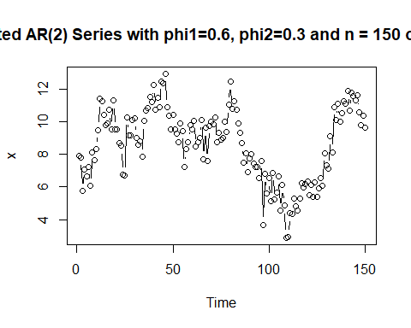

#The above plot command plots lags versus the ACF values for lags 1 to 10. The ylab parameter labels the y-axis and the "main" parameter puts a title on the plot.

# Draw ACF plot for AR(2) model  
acf(x, xlim=c(1,10), main="ACF for simulated AR(2) Data with phi1=0.6, phi2=0.3 and n = 150 observation")

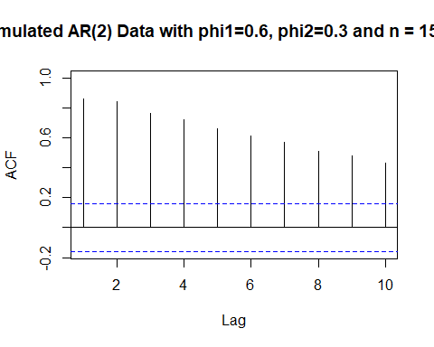

# For b) AR(2) with phi1=-0.4, phi2=0.5  
xc=arima.sim(n=150, list(ar=c(-0.4, 0.5)))   
#simulated n = 150 values from this model and plotted the sample time series and the sample ACF for the simulated data.  
x=xc+10 # adds 10 to make mean = 10. Simulation defaults to mean = 0.  
plot(x, type="b", main = "Simulated AR(2) Series with phi1=-0.4, phi2=0.5 and n = 150 observation")

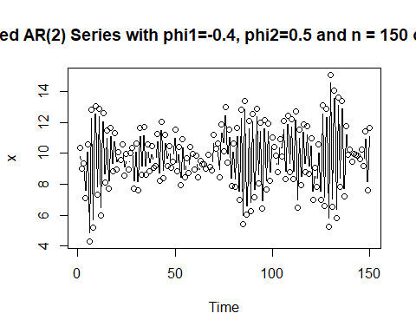

#The above plot command plots lags versus the ACF values for lags 1 to 10. The ylab parameter labels the y-axis and the "main" parameter puts a title on the plot.

# Draw ACF plot for AR(2) model  
acf(x, xlim=c(1,10), main="ACF for simulated AR(2) Data with phi1=-0.4, phi2=0.5 and n = 150 observation")

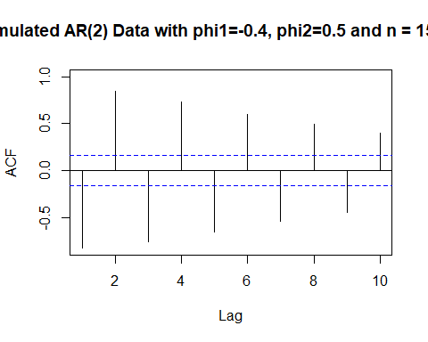

# For c) AR(2) with phi1=1.2, phi2=-0.7  
xc=arima.sim(n=150, list(ar=c(1.2, -0.7)))   
#simulated n = 150 values from this model and plotted the sample time series and the sample ACF for the simulated data.  
x=xc+10 # adds 10 to make mean = 10. Simulation defaults to mean = 0.  
plot(x, type="b", main = "Simulated AR(2) Series with phi1=1.2, phi2=-0.7 and n = 150 observation")

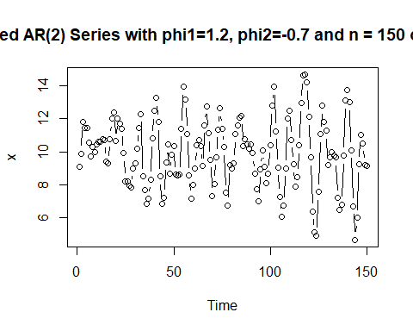

#The above plot command plots lags versus the ACF values for lags 1 to 10. The ylab parameter labels the y-axis and the "main" parameter puts a title on the plot.

# Draw ACF plot for AR(2) model  
acf(x, xlim=c(1,10), main="ACF for simulated AR(2) Data with phi1=1.2, phi2=-0.7 and n = 150 observation")

